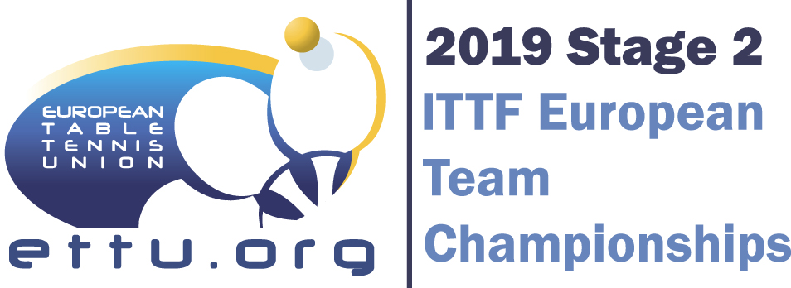 | REFEREE REPORT | 2018-19 ITTF EUROPEAN CHAMPIONSHIPS
 |  | Stage 2

1. COMPETITION ESSENTIALS
COMPETITION (gender/division/stage)
HOME ASSOCIATION
VISITING ASSOCIATION
DATE |  |  |  |  | CITY
TIME (start/end) |  |  |  |  | HALL
 | Name |  |  |  |  | Association | IR | IU | NU | IU N°
REFEREE
UMPIRE
UMPIRE

- PLAYING CONDITIONS
Size of Court (length x width x height)
 | Colour |  |  | Brand / Type
FLOOR
SURROUNDS
TABLE
NET
BALL | white |  |  | Nittaku Premium ***
SCORE INDICATOR (number) |  |  | 2
LIGHT |  | In the hall |  | lux | Above the table | lux
TEMPERATURE |  | measured |  | deg.C | or estimated | deg. C

3. PLAYERS’ CLOTHING
 | Home Association | Visiting Association
Colour(s) of Shirt
Colour(s) of Short
Uniformly dressed (shirt/shorts)
Advertisement(OK/ not OK)

4. PUBLICITY
Number of spectators (estimated if no exact count)
TV COVERAGE (country/exact name of the television station/details about minutes) |  |  | yes live no

5. COMMENTS

It is necessary that the nominated referee gives exact information about number of spectators and TV Coverage (exact names of TV Station covering the event; duration of transmission, etc.).
The Referee Report to be returned within 24 hours after the match is played to: Zita PIDL E-mail zpidl.ettu@gmail.com with cc to ettu@pt.lu

