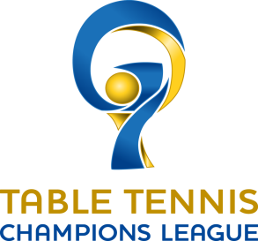

TTCLM Post Event Report

  - EDITION 2017/18

TTCLM Post Event Report
This short Report must be sent to the ETTU and tsmg latest within 48h after the end of the match.
It includes the following information:

- Marketing Material

Please let us know us know about the marketing activities that you have implemented/created for the match.
For example printed posters, programme leaflets, brochures, information for supporters, hand-outs, etc. (photos, screenshots are sufficient)

- Number of spectators

Number of sold tickets:

Normal: XX
VIP: XX

- Press activities from the club and the local press

Please let us know if there were any press articles/releases, match announcements in your (local) newspaper.

Name of the newspaper: Name of the newspaper:
Length of article: Length of article:
Publication date: Publication date:

Name of the newspaper: Name of the newspaper:
Length of article: Length of article:
Publication date: Publication date:

- Additional entertainment activities organized

Please let us know if you have organized additional entertainment activities (e.g. media activities, activities for supporters).

No:
Yes, we have organized the following activities:
- Xxx
- Xxx

